**ANALYSIS OF CARGO THEFT DATA**

Throughout the analysis of the dataset, I have taken a question-answer based approach to understanding the data. Below are the insights I gained from the analysis:

* The data contain approximately **193 thousand** records of cargo thefts which dates from 2012 to 2022 with the highest number of thefts committed in 2021 **(41 thousand)**. It will be worthwhile further investing how the number of crime suddenly skyrockets between 2018 and 2019.

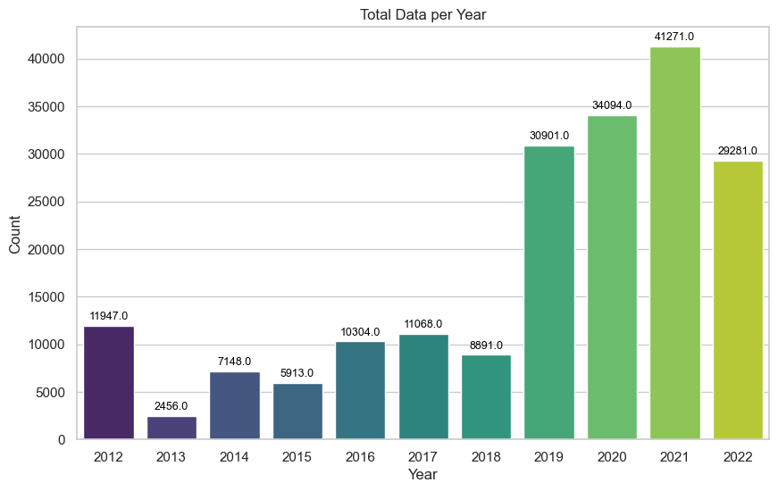

* **The most common type of offense committed is theft from motor vehicle.**

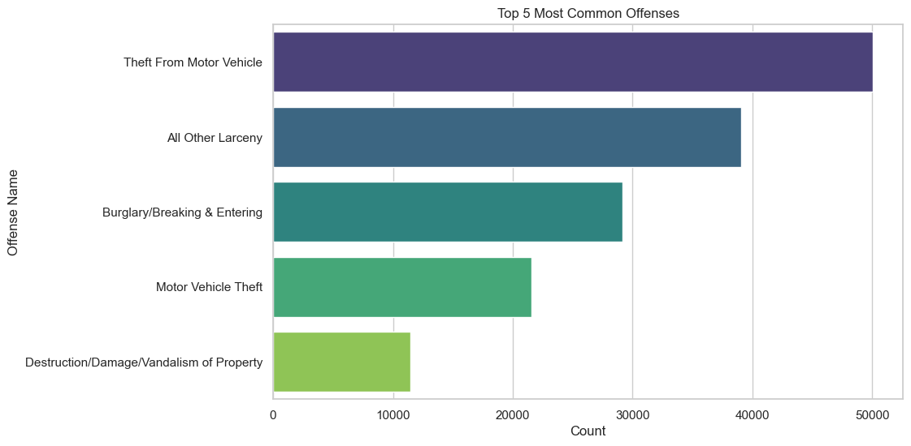

* People from **Non Hispanic and Latin ethnicity group appear to have committed the highest number of crime.**

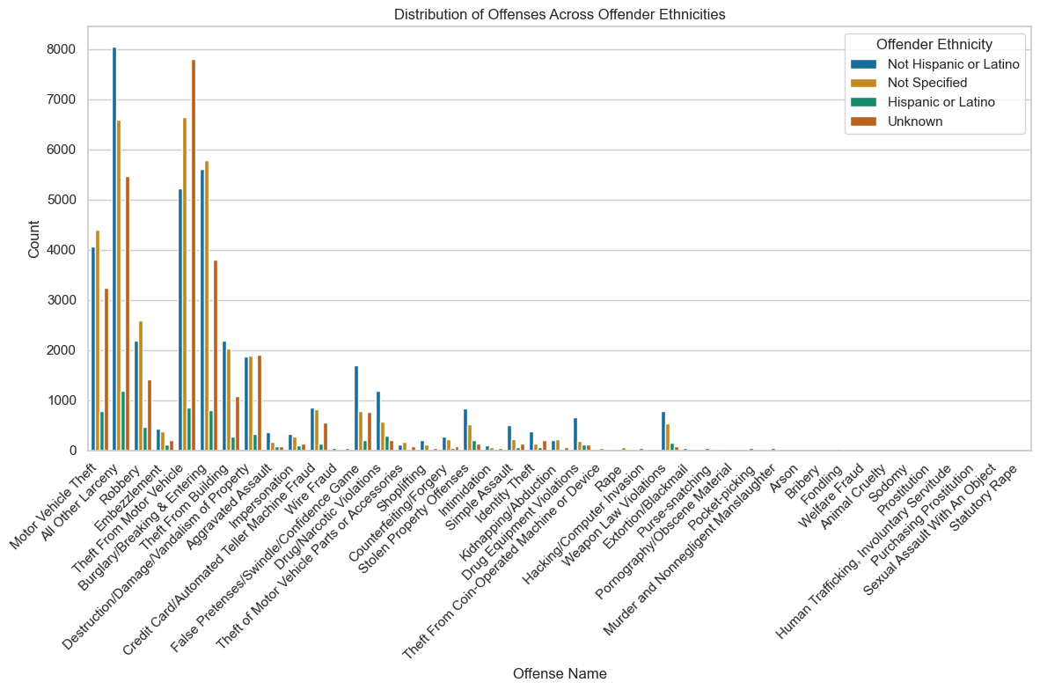

* Across the years, it seems the performance of enforcement agencies has not been effective in terms of recovering stolen items as the **number of recovered items keep decreasing while number of unrecovered items keep increasing drastically**.

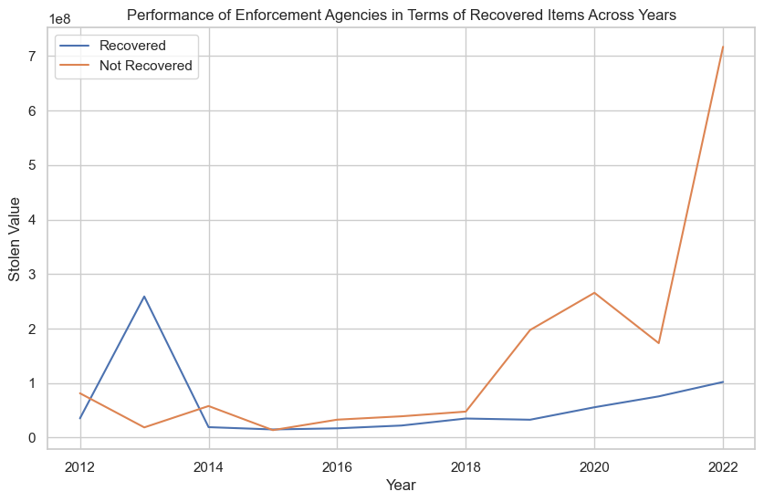

* The **male gender is more involved in crime** than all the other gender combined.

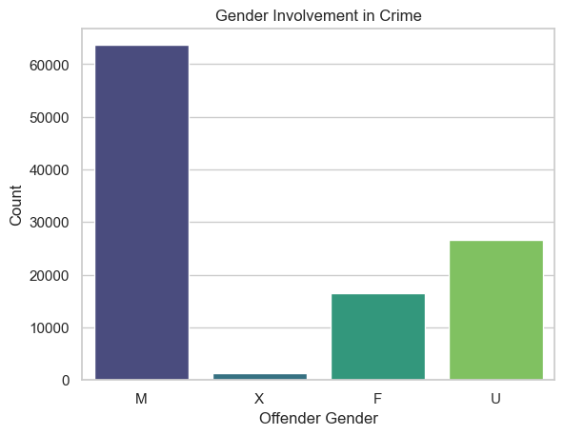

* It can be observed that **White people committed more crimes than Black people** across all the categories of top crimes

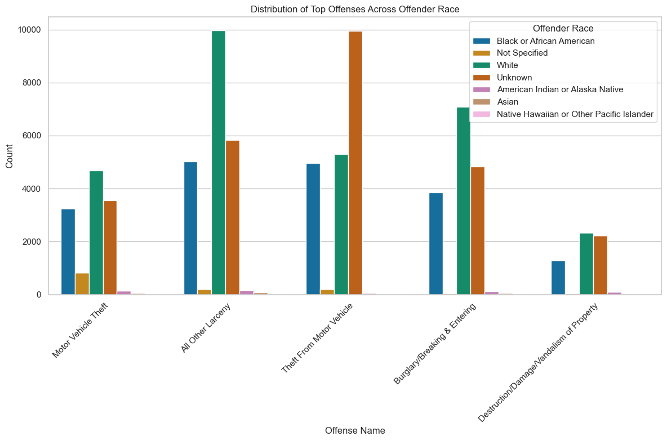

* Another crucial observation is that people who commit crimes tend to use **Handgun and Personal Weapons.**

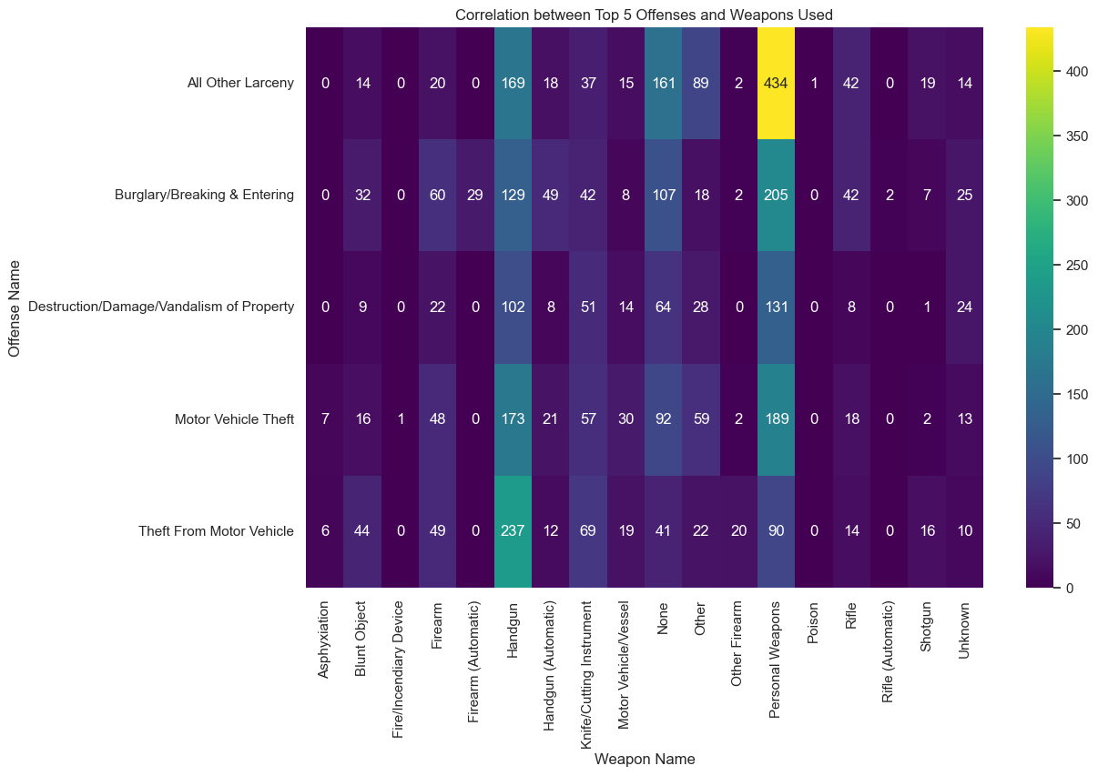

* In 2015, law enforcement agencies experienced their most successful year in terms of the value of recovered items.

